Project Development Phase
Model Performance Test

Date | 30 September 2026
Team ID | MKU201Team56ab4dc836f290be8a6b49be8
Project Name | Import Data Using Transform Maps (ServiceNow Micro Project)
Maximum Marks | 10 Marks

Model Performance Testing:
Project team shall fill the following information in model performance testing template.
S.No. | Parameter | Values | Screenshot
- 1. | Model Summary | ServiceNow data-import automation using Import Sets, Transform Map and Coalesce: spreadsheet → u_employee_import → u_employee_test, with three reports and a dashboard.  Note: rows whose fields map correctly are created / updated in Employee Test; unmapped or invalid data produces errors in the import log. | 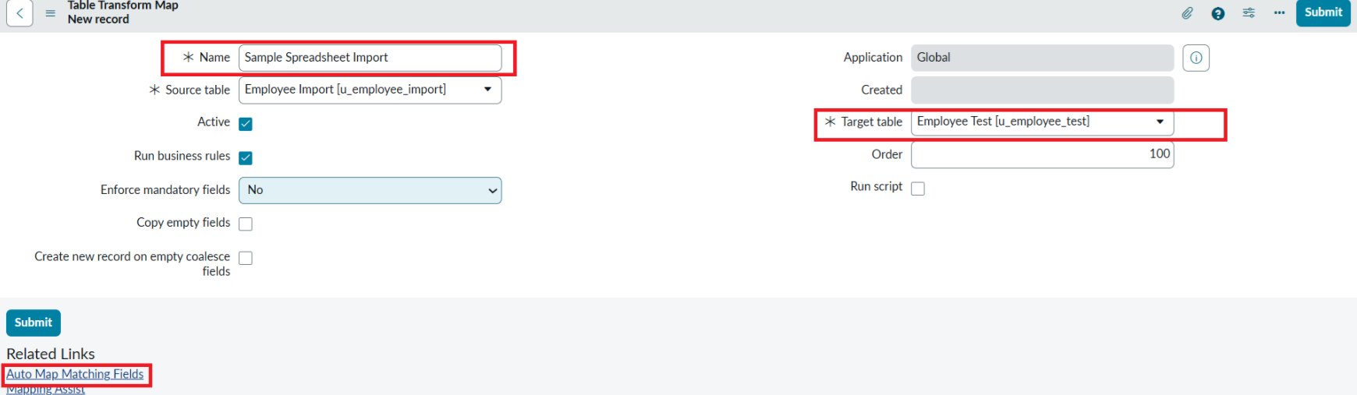
- 2. | Accuracy | Field mapping: 5 of 5 fields mapped (Employee ID, Name, Email, Department, Location).  Import validation: imported rows compared with source spreadsheet; record count and values match (Phase 5).  Duplicate check: re-import of the same file produces no additional inserts (Coalesce on Employee ID). | - 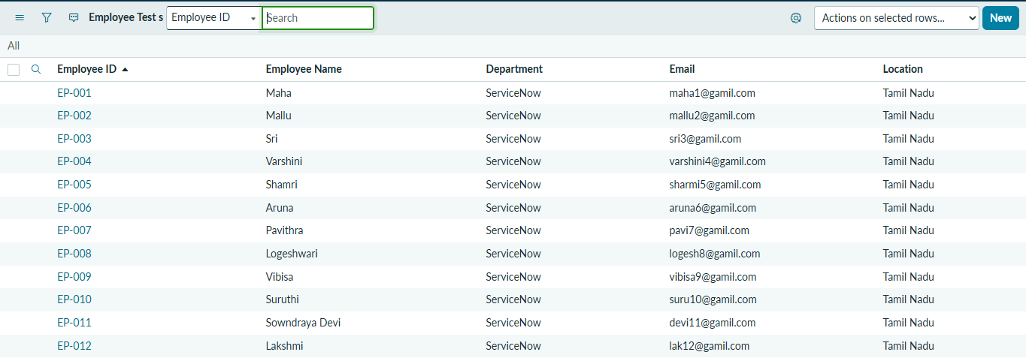
3. | Coalesce / Update Test | Updated file with 4 rows: 2 existing Employee IDs updated, 2 new IDs inserted. | 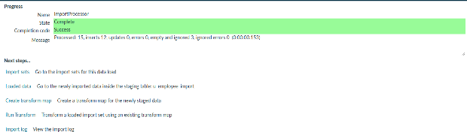
4. | Reports & Dashboard | 3 reports (Pie, Bar, List) and 1 dashboard 'Employee Analytics Dashboards' with 3 widgets. | 